**EXERCISE 06**

**Source Code**

sbit Brake at RA2_bit;

char forwardDone = 0;

void main() {

CMCON = 0x07;

TRISA = 0x07;

TRISB = 0x00;

PORTB = 0x00;

while(1) {

if (!Forward && forwardDone == 0 ) {

PORTB = 0x00;

RB0_bit = 1;

RB1_bit = 0;

RB2_bit = 1;

// Wait 10 seconds

Delay_ms(1000);

PORTB = 0x00; // Stop motor

}

else if (!Reverse) {

PORTB = 0x00;

RB0_bit = 1;

RB1_bit = 1;

RB2_bit = 0;

}

else if (!Brake) {

PORTB = 0x00;

}

}

}

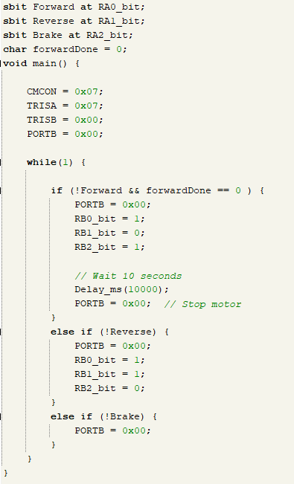

**Circuit**

